**Day 1 assignment**: Difference between Report and Dashboard

|  |  |  |
| --- | --- | --- |
| Feature | Report | Dashboard |
| Definition | Multi-perspective detailed view of the dataset. | Single page overview from multiple datasets. |
| Pages | Multi-page | Single page |
| Interactivity | Highly interactive, detailed exploration | Limited interactive, high level view. |
| Data source | Single dataset. | Multi dataset |
| purpose | Detailed analysis and deep dive into data. | High-level overview and monitoring. |
| Customization | Extensive formatting and customization | Layout customization and pinning reports. |
| Usage | In-depth data analysis. | Quick overview. |

**Day 2 assignment**: Difference between Import method, Direct query and live connection.

|  |  |  |  |
| --- | --- | --- | --- |
| Feature | Import Method | Direct Query | Live Connection |
| Data storage | In-memory storage in power BI | Queries live data source | Queries live Analysis Services model or power BI Dataset |
| Performance | Fast | Depends on dataset performance. | Depends on the Analysis Services performance. |
| Data Refresh | Periodic refresh needed. | Real-time data access. | Real-time data access. |
| Transformation | Extensive transformation in power BI. | Limited transformation in power Query. | Transformation in Analysis Services. |
| Data Volume | Suitable for moderate sized datasets. | Suitable for large dataset. | Suitable for large and complex models. |
| Offline Capability | Available | Not available | Not available |
| Source load | No load on data source after import. | Load on data source for each query. | Load on Analysis services for each query. |

**Day 3 assignment**: Connect with SQL SERVER AdventureWorks database, pick few tables and make relevant relationship between them.

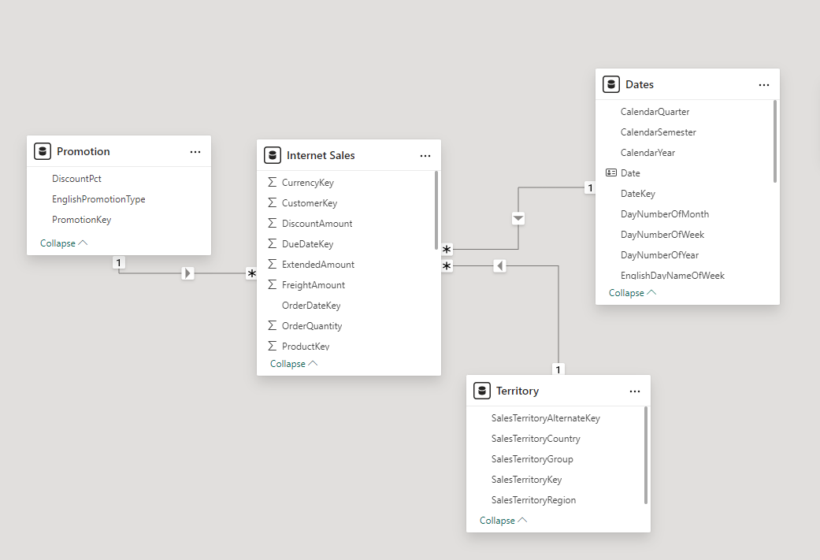

**Day 4 assignment**: Types of licenses used in power BI and refresh timing.

1. Power BI free: This license is free for all and offers basic features for personal use.

* Create and share reports and dashboards with oneself.
* Connect to over 70 data sources.
* Publish reports to the power BI service.

Refresh timing: up to 8 times per day.

Max size: 1GB

1. Power BI pro: This is a paid license aimed at small to medium-sized teams and organizations that need collaboration features.

* All features of power BI free.
* Share and collaborate reports and dashboards with all the users.
* Export to PowerPoint, Excel and CSV.
* Data governance and security.

Refresh Timing: Up to 8 times per day.

Maxi size: 1GB per dataset.

1. Power BI Premium Per User (PPU): This is a per person premium and provides premium features to an individual.

* All features of power BI pro.
* AI capabilities and AutoML.
* Paginated reports.
* Larger data sets and more frequent refreshes.
* Access to on-premises Power BI Report server.

Refreshing Timing: Up to 48 times per day.

Max Size: 100 GB per dataset.

1. Power BI Premium capacity: This is an enterprise-level offering that provides dedicated cloud capacity and extensive features for large organizations.

* All features of Power BI Pro and PPU.
* Dedicated capacity in the power BI Service.

Refresh Timing: Up to 48 times per day.

Max Size: 400GB per dataset.

1. Power BI Embedded: Aimed at developers who want to embed Power BI reports and dashboards into their own applications.

* All features of Power BI Premium capacity.
* Embedding capabilities for ISVs (Independent Software Vendors) and developers.
* API access for automation and integration.

Data Refresh: Up to 48 times per day.

Max Size: 400 GB per dataset.

Day 5 assignment: How do we import visuals from MarketPlace?

1. Open power BI desktop
2. Create new or open existing reports.
3. Navigate to the visualizations pane.
4. Click on the ‘...’ (Ellipsis) icon.
5. Select ‘Get more visuals’.
6. Browse or search for visuals.
7. Add the visual for your report.
8. Confirm the addition.
9. Use the imported model.
10. Customize and use the visual.

**Power BI Architecture**

